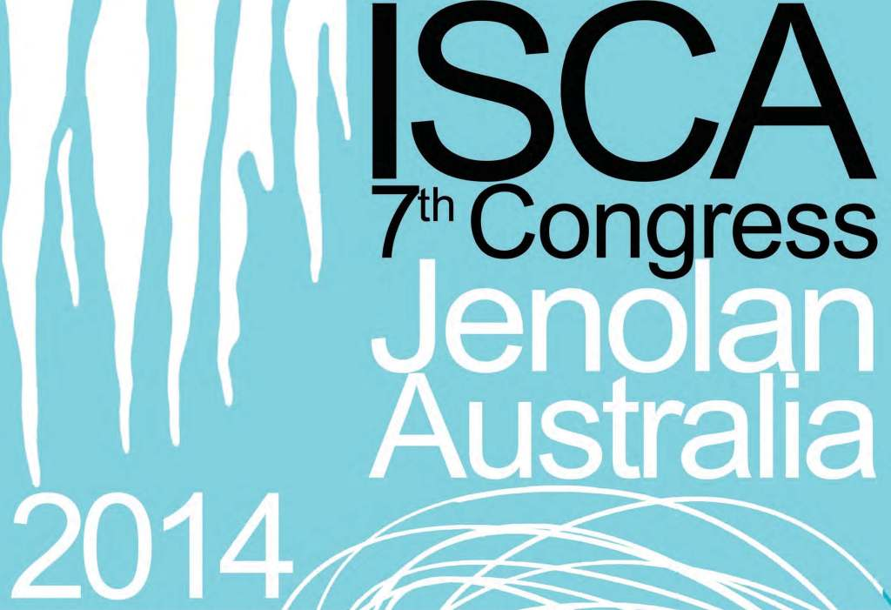 | International Show Cave Association 7th Congress of ISCA  Jenolan Caves 2 - 8 November 2014  Congress Registration Form  Please use this form to provide details and to confirm attending this Congress and what additional options (e.g. pre and post Congress trips) you wish to attend. Please note that there are limited spaces for pre and post congress trips and partner program. These will be allocated on a first come first served basis.  All costs are in Australian dollars ($AUD).

Personal Information
Name/s
Include all individuals from your site attending
Organisation / background
Final copy will be published in Congress handbook
Mailing Address
Email: |  |  | Telephone number:
Preference for Congress Accommodation (Refer to accommodation guide – credit card details are required to confirm accommodation. Payment can be made in advance or on check out. There is a 2.5% fee applied to payments made with AMEX or Diners cards. Please note cancellation fees do apply if cancelling within 14days of arrival)
First Preference  Accommodation area ___________________ |  |  |  | Room Type _____
Second Preference  Accommodation area ___________________ |  |  |  | Room Type _____
If choosing Gatehouse accommodation please indicate if Linen is required: Yes/No
If shared, who are you sharing with?
If choosing Gatehouse, Binoomea Cottage, Jenolan Caves Cottages, Classic Family and Traditional Family Rooms (share accommodation) but have not indicated who you are sharing with please indicate if you are happy to share with other congress attendees and split room costs. Yes/No
Please indicate dates required for accommodation:
Check-in ____/__/2014 Check-out ___/11/2014
Transport to Jenolan Caves and back to Sydney
Pre: Own Transport, Sydney to Jenolan
Pre: Sunday 2nd November bus Sydney to Jenolan |  |  |  |  | No. of seats ( ) |  | Cost included in Registration
Post: Sunday 9th November bus Jenolan to Sydney |  |  |  |  | No. of seats ( )
Pre and Post Congress Organised Trips (prices are per person)
Pre-Congress Sydney Attractions - based in Sydney, October 30th -November 1st(expected maximum including optional activities $411, excluding meals/accommodation) Limit 40 – minimum 12 participants. A detailed itinerary of activities will be forwarded by email. |  |  |  |  |  |  | No. of places ( )
Post-Congress Australian East Coast Caves, 6 days (cost $900– includes transport, accommodation, meals) Limit 40 |  |  |  |  |  |  | No. of places ( )

Partners Program
A program of local activities on Monday, Tuesday & Friday for partners of attendees who would prefer to explore rather than attend sessions Limit 24 - minimum numbers apply | No. of places ( )

Congress Convenor: Dan Cove, Jenolan Caves Reserve Trust.
dan.cove@jenolancaves.org.au www.jenolan2014.com
Skype: dan.cove Mobile (Cell): +61 458 201724
Phone: +61 2 6359 3926 Fax: +61 26359 3307

Conference fees |  |  | Your cost
Registration |  | AUD$1200. Includes all meals, in-Congress transport, transfers to and from Congress Venue, venue hire and extras. Includes Sunday welcome dinner and final Saturday night Congress dinner as well as field trips and activities. Includes daily late afternoon drinks. Does not include all beverages.
Partner fees |  |  | Your cost
 |  | AUD$1200. Includes all meals, in-Congress transport, transfers to and from Congress Venue. Includes Sunday welcome dinner and final Saturday night Congress dinner as well as field trips and activities. Includes daily late afternoon drinks. Does not include all beverages.
How you will be able to pay – options
A | Direct credit into Jenolan account (our preference). Payments may be made in several instalments.
B | Credit cards.  Visa, MasterCard, Diners and American Express all accepted.

Other details
Please advise the Congress Convenor here if you have any special requirements, e.g. dietary – vegetarian, gluten free, dairy free, disabilities or mobility issues, invoice required etc. We will contact you by email.

International Show Cave Association 7th Congress of ISCA

Jenolan Caves 2 - 8 November 2014

Congress Registration Form - Information

Welcome
Jenolan Caves look forward to hosting you at the 2014 ISCA Congress. The Congress theme is ‘The challenge of sustainably showing caves in the 21st Century’. Further general information on the Congress will be published in Congress Newsletters, on the ISCA website and on the official Congress website www.jenolan2014.com.

Congress programme
The Congress programme will be published on the ISCA and Congress websites prior to the Congress. On most afternoonsthere are a variety of activitiesand/or excursion options, places for these will be allocated on the first day of the Congress according to interest levels. There will be a full day excursion on Wednesday November 5th to visit the highlights of the Greater Blue Mountains World Heritage Area.

Papers guide
An initial call for papers was issued in December 2013. Please submit abstracts to the panel by the advisedcut off date of 30th June. All papers will be 20 minutes with 5 minutes for questions.
With a limit of 25 paper slots, the Congress organisers do reserve the right to decline papers. We will try to advise speakers as soon as possible.

Pre- and post- Congress trips
There are two planned official Congress trips. A pre-congress trip will be based in Sydney, and offer a hosted tour of the major attractions of the city with the advantage of local knowledge. The post-Congress trip will travel from Jenolan Caves to the city of Melbourne via the major Australian east-coast show caves of Wombeyan, Yarrongobilly and Buchan. Expected costs are given in the registration form. The price for the post Congress trip includes transport, accommodation, meals and accompanying hosts. The organisers will try to provide flexibility in eating and accommodation options for the group. Those indicating interest in these programmes will be contacted with further details.

We will contact those registering for the ‘partners programme’ and discuss the local options before finalising this itinerary.

Congress clothing guide

Please indicate the articles of official Congress clothing required. Orders must be received no later than August 15th 2014

Please see clothing order form below

Official Congress Clothing Order Form:
Please be aware that orders must be received no later than 15th August 2014.
If additional items are ordered after this date we cannot guarantee the item being available for pick up during the conference.
T-Shirts

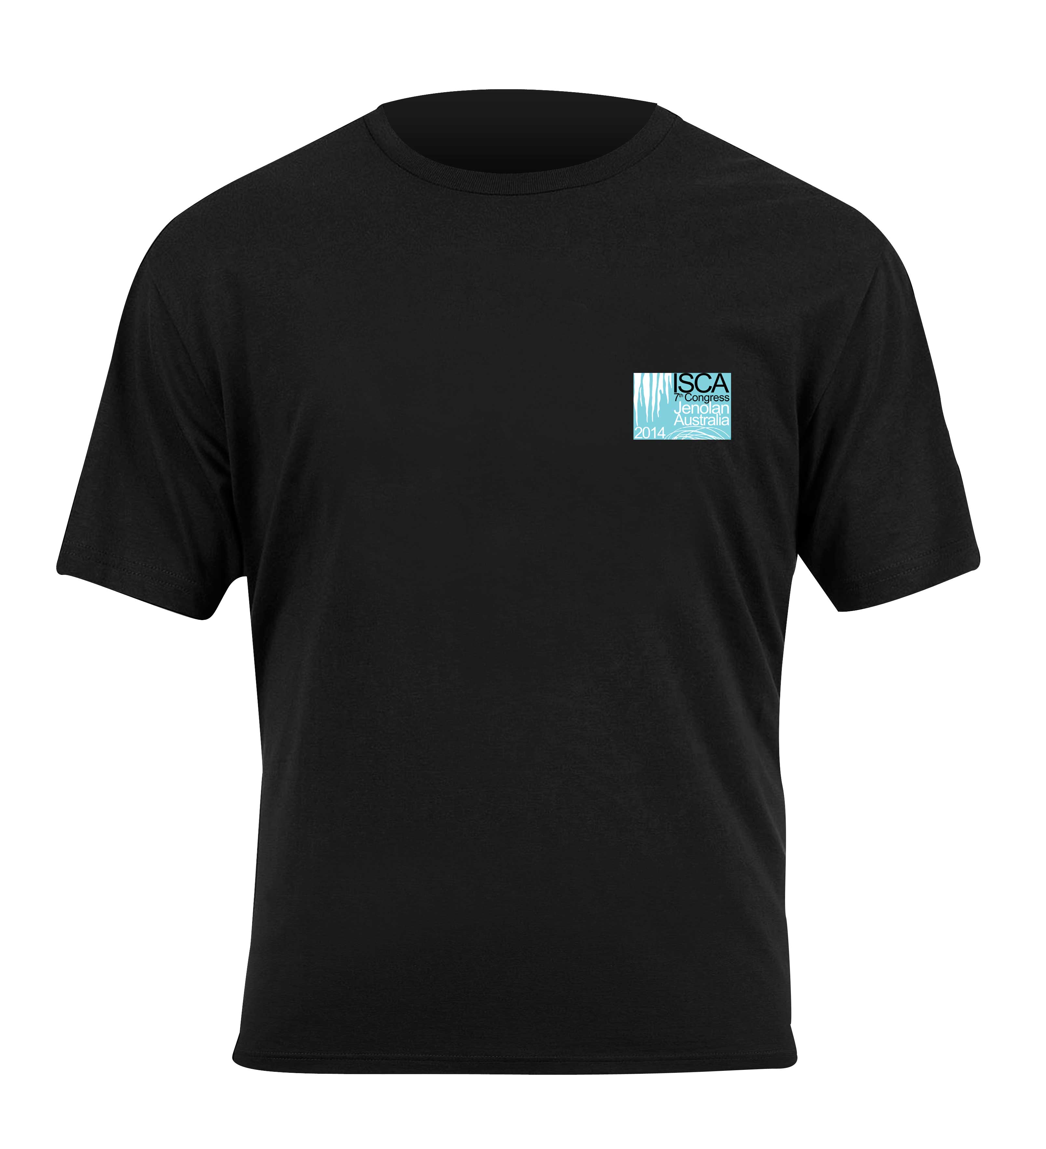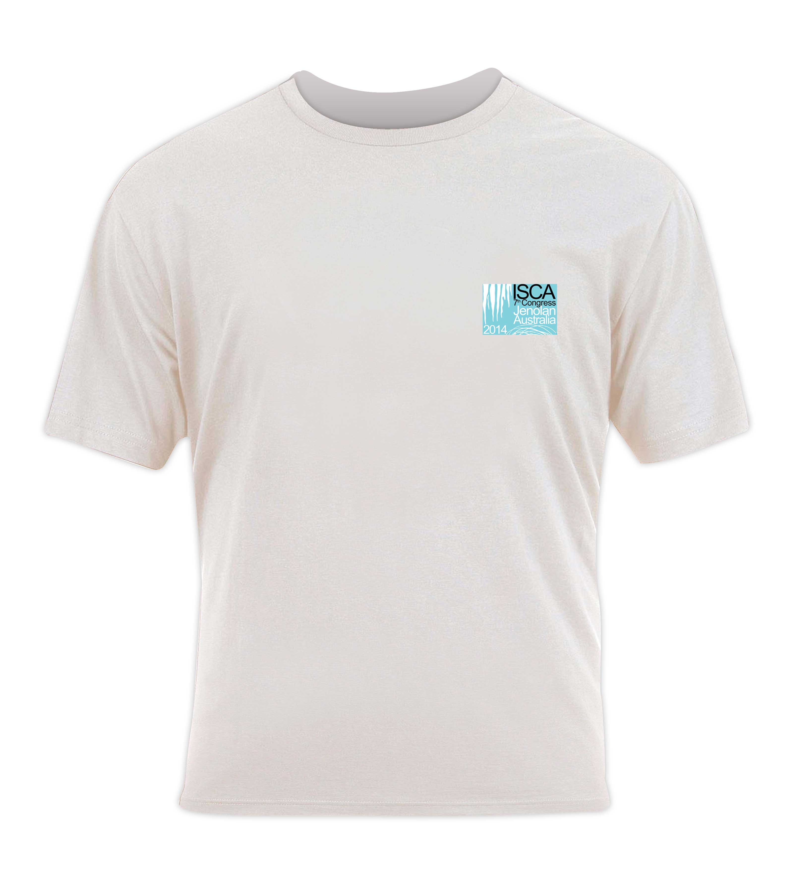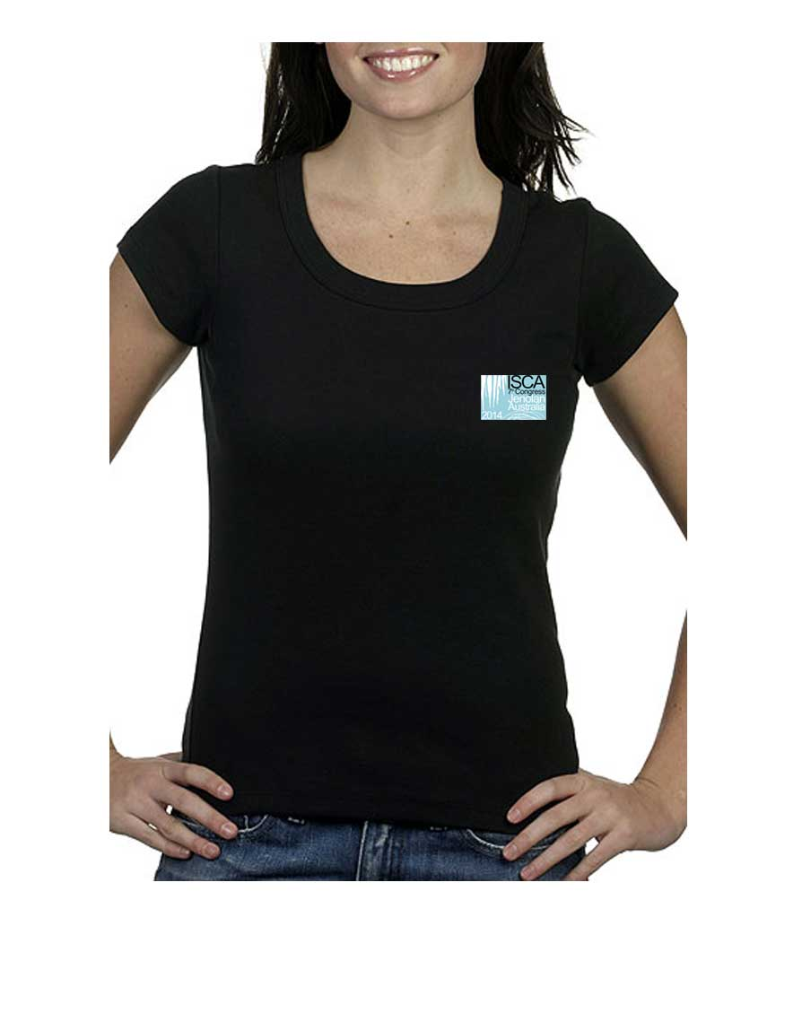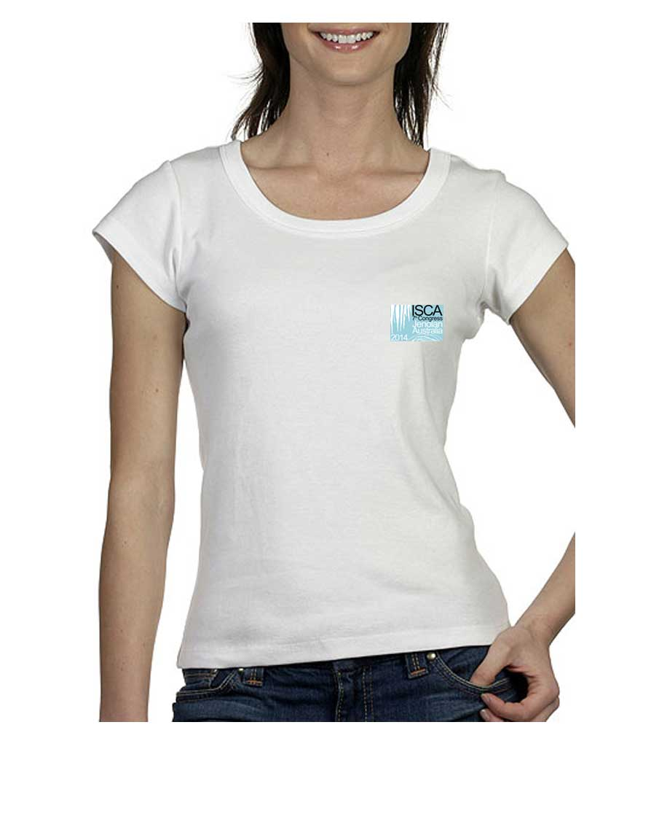

Polo Shirts Polar fleece
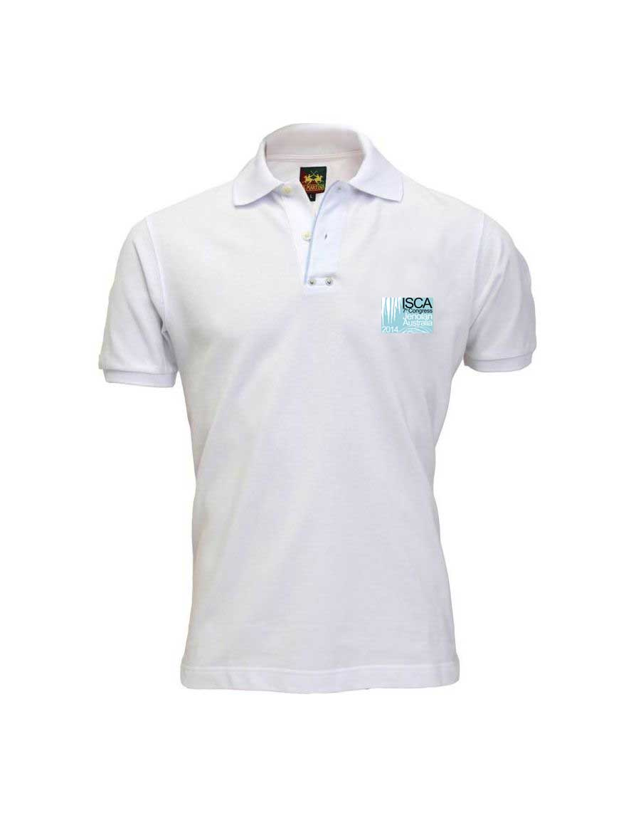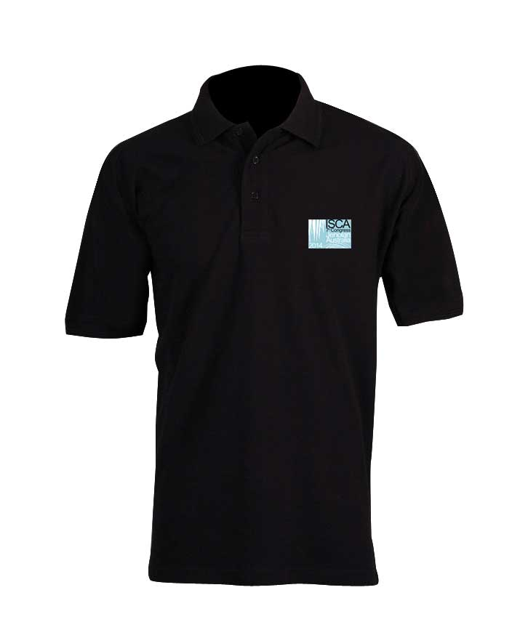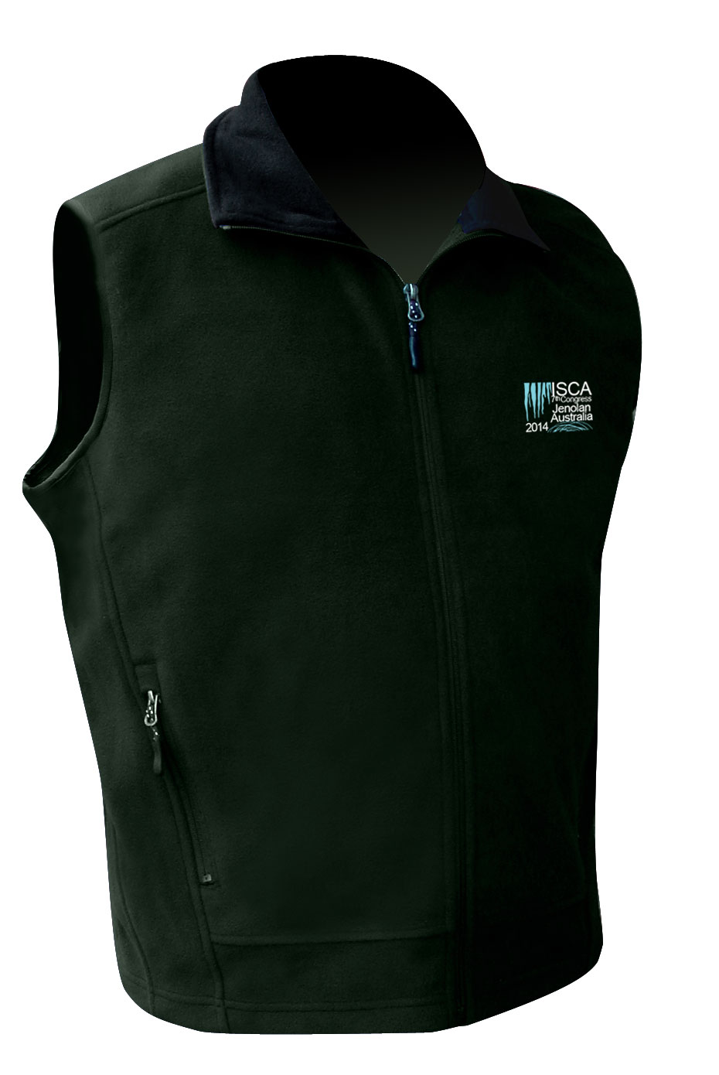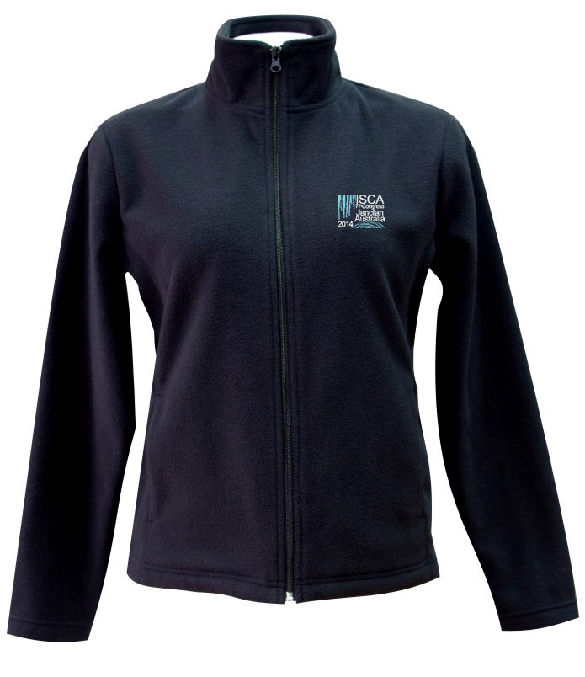

 | QUANTITY | Black | White | Size | Total $
T-Shirts
Men’s Classic T-Shirt (S-5XL) $15
Women’s Scoop Neck T-Shirt (8-18) $16
Polo Shirts
Men’s Cotton Polo Shirt (S-5XL) $20
Women’s Cotton Polo Shirt (8-24) $20
Polar Fleece Vest & Jackets
Polar fleece Vest (S-5XL) $28
Polar fleece Vest (8-24) $28
Polar fleece Jacket (full zip) (S-5XL) $35
Polar fleece Jacket (full zip) (8-24) $35
 |  |  |  | Grand Total | $
Accommodation Guide
- All prices are per night in AUD($) and include Goods and Services Tax (GST)
- All accommodation listed is located at Jenolan Caves within close walking distance of the Congress Venue except the Jenolan Caves Cottages 8km distant. A shuttle bus will provide transport to and from these cottages to the Congress venue daily.
- There are other accommodation options a 30 minute drive from Jenolan Caves in the nearby town of Oberon. For these alternative options please email Jenolan Caves dan.cove@jenolancaves.org.au and quote ‘ISCA Congress 2014’ in the subject line
- Accommodation will be allocated on a first come first served basis, and early booking is strongly recommended.
Jenolan Caves House | Rate (Per Night twin share) | Description
Grand Classic Room | $170 | Charming period furnishings, tea & coffee making facilities, queen-size beds (classic rooms), king-size beds (grand classic rooms; 7of these rooms can be adapted to a twin share option) and private modern en-suites. There are 2 Classic Family rooms featuring a queen size bed and a set of bunks and private modern en-suite.
Classic Room – SOLD OUT  PLEASE NOTE there are now only 2 Classic Family Rooms left – these need to have a minimum of 3 people occupancy | $123  An additional $30 per night per person(above 2people) applies to Family rooms
Traditional Room (shared amenities)  PLEASE NOTE Traditional Family Rooms need to have a minimum of 3 people occupancy | $79  An additional $30 per night per person(above 2people) applies to Family rooms | Traditional rooms contain washbasin, charming period furnishings, and queen-size bed. We also have 2 traditional family rooms (queen bed + bunks) as well as twin rooms (2 single beds) available.  There are modern shared bathrooms a very short distance from each room.
The Mountain Lodge | Rate (Per Night twin share) | Motel-style rooms with spacious en-suites (with bathtubs), kitchenette with refrigerator and microwave, as well as telephone and television.
Family Room | $125 ($30 per extra person)
King or King and single Room | $125 ($30 per extra person)
The GateHouse | Rate (Per person) | Quad rooms contain a double bed and set of bunks. Family rooms contain 3 sets of bunks. There are shared bathroom facilities on each floor and two common rooms, each with television and food preparation facilities.Note: Cost does not include linen which can be hired at a one off charge of $14 per person for the week
6 Berth Room (Family Room) | $32 (minimum 2 per room)
4 Berth Room (Quad Room) | $32 (minimum 2 per room)
The Binoomea Cottage | Rate (Per Night) | There are 2 floors (apartments). Perfect for large share groups, each apartment is capable of sleeping 12, with three large bedrooms, each with a king bed (can be split) and set of bunks. Each apartment also features a huge bathroom,self-contained kitchenette/dining/lounge room with TV and phone.
Per Apartment (Sleeps 12) | $275 (up to 6)  $20 per additional person
Jenolan Caves Cottages | Rate (Per Night) | Each cottage can sleep up to six people in two separate bedrooms. Double bed in main and two sets of bunks in second room. The cottages include TVs and are fully serviced. The kitchens are equipped with gas stove, oven, microwave oven, refrigerator, sink and breakfast bar.
Cottage – up to 6 berth | $150



