Modern safety solutions for LED lighting systems
Power surge protection prevents damage!

Operational breakdown due to lightning or power surge (also: voltage spikes or overvoltage) is a theme well known to show cave operators because failure of the lighting system and also of the telephone, computer and box office operation is annoying and may well bring guided tours to a standstill. Therefore one wishes for trouble-free operation of all electrical equipment. Our long-standing experience reveals an accumulating demand in this field, especially in show caves.
This objective can be achieved using a comprehensive protection concept. Economically conscious operators should therefore invest in overvoltage protection. The investment costs a mere fraction of the expense that may occur following a lightning strike or other form of power surge. A lapse in operation and/ or the safety-relevant failure of the path lighting can be extremely costly. Not only the considerable amount of expenditure needed to rectify the damage and the loss of custom are aggravating, the impairment in the durability of electrical components such as LEDs must also be taken into account.
The threat of damage caused by power surge is therefore considerable! Good examples of overvoltage protection designed by us are the show caves Höllgrotten-Baar (lightning strike during a thunderstorm) and Wendelstein (lightning strike, exposed site on a summit almost 2000 m above sea level. Both installations are now running trouble free.
Generally speaking, all electrical and conductive materials are threatened by overvoltage, beginning with the high tension power cable to the administration building, box office and its systems; the cable leading to the cave right down to the last components, e.g. the LED lamps.
Only a well-conceived overall system can provide effective protection for all parts of the show cave. Protection against power surge demands expert knowledge. It is in general a very complex matter. The protection demands not only one component but a combination of several elements and requires special engineering knowledge, also in its development, installation and application.

How and by what means does power surge occur?
It arises for example from switching operations in transformer substations (voltage fluctuation) of the energy supplier, from lightning during thunderstorms, from electrostatic discharge, switching faults or the triggering of fuses. The possibilities of penetrating the electrical system of a show cave are multiple and may ensue from galvanic, inductive, capacitive means; through light radiation, transient switching operations, interference voltage, symmetrical interference, transverse voltage, asymmetrical (common-mode) interference, longitudinal voltage, etc.

Power surge occurring during a thunderstorm is caused by direct, nearby or even distant lightning strike. Direct or nearby lightning strike is a discharge into the lightning conductor (if existing) of a building (administration, box office) or into the conducting electrical elements entering the building or cave (e.g. cables for the power source, telephone, control and security systems, etc.). Due to their amplitude and energy content, the arising currents and voltages as well as the ensuing electromagnetic field present a particular threat to the installation. The power surge occurring from a direct or nearby lightning strike arises from voltage drop at the earth resistance and the resulting rise in potential of building or cave compared to the distant surroundings. This represents the highest form of electrical stress.
In addition to the voltage drop at the earth resistance overvoltage arises from the induction voltage of the lightning field. The energy of this induced overvoltage and the thereby ensuing impulse current is significantly less than that of a direct lightning strike.
A power surge exceeds the required tension, i.e. the voltage for which the insulation is designed and tested to comply to. The relevant specifications vary according to the electrical components. The insulation of a 230 V. component such as an electric motor is tested with several kilovolts. It is easy to understand that a 24 V DC LED lamp with internal electronic components cannot have the same insulation resistance! Even 50 volts may disable it.
Overvoltage is an extremely high tension with quick rising edges in the microsecond range (0,000 001 of a second) which can damage or even destroy the insulation and function of electrical and electronic components. Each electrical unit is insulated to separate the power from earth or from other live components. The level of insulation resistance depends upon the rated voltage and the type of component and is stipulated by legal requirements. It is tested under the required voltage over a specified period of time. For the CE and UL approval of our LEDs the insulation was successfully tested. Furthermore, suppressor diodes are also incorporated in our LED lamps.
Lasting, that is, permanent increases in voltage in normal 400V/230V/50Hz power supplies can occur and present a further demand for protection against overvoltage.
Due to their physical origins voltage spikes have a high frequency and compared with 50Hz voltage have an approximately 10,000 times steeper current rise. These spikes are fast, short duration electrical transients in voltage. Progression and frequency depend greatly on the impedance of the circuit.
Therefore, beside the building’s lightning conductor further measures must be taken to protect modern LED lighting systems from overvoltage. Here it is important to take all possible causes into account. This topic is as already described, very complex and within caves difficult to realise.
Here we describe a general approach to the solution.

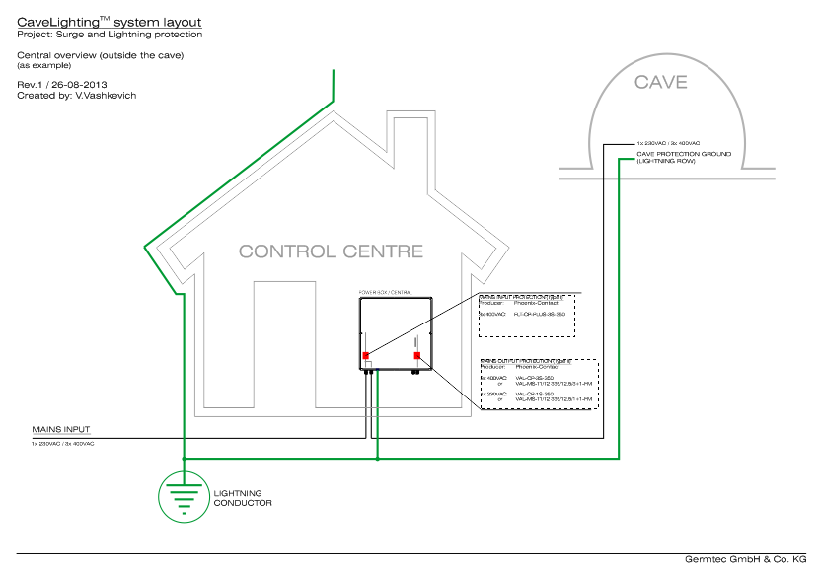
Illustration 1: An example with a schematic illustration of the main distribution and protection measures in the administrative building or box office of a show cave.

The protection zones concept
It is important to differentiate between zones of varying hazard. The necessary protective measures against lightning strike and overvoltage, particularly the required appliances and components, can be determined according to these zones.
The following belong in a protection zones concept:
- external lightning protection: arrester, conductor and earthing
- electrical bonding
- shielding
- overvoltage protection for the power and information system

The concept defines the following zones which differentiate according to their possible load due to lightning strikes and electromagnetic fields.
Zone 0_{A}: | direct lightning strike possible (highest load).
Zone 0_{B}: | within an area protected by an arrester or a building; unsuppressed electromagnetic area.
Zone 1: | area with electromagnetic fields reduced by shielding.
Zone 2: | area further protected by shielding.

The electrical bonding is very important at every zone transition!

According to their requirements the protection zones are divided thus:
- lightning conductor (0_{A} in 1)
- overvoltage arrester
- combined arrester (0_{A} in 2)

For terminal appliances such as in LED illumination overvoltage arresters are important. It is their task to further reduce the residual energy from the preceding protection stages as well as overvoltage induced or self generated within the system.

Generally speaking:
- show caves and their buildings are threatened due to their exposed sites
- failure due to lightning strike and overvoltage is possible
- high repair costs are often the result
- LED systems should be integrated in already existing lightning/earthing concepts (if non-existent they should be planned anew)
- special protection measures through coordinated overvoltage protection components according to the protection zones concept are required
- protection for the building AND the lighting system in the cave is necessary to prolong the availability and safeguard the investment
- overvoltage protection is an important part of the EMC (electromagnetic compatibility) and required by law

How can power surge protection be achieved?
It can be differentiated between:
General protection measures when planning building and electrical installation
- earthing system and electrical bonding
- physical separation when installing differing nominal voltages (min. 0.5 m!)
- division into separate protection zones
Special protection measures
- power surge protection components
- reduction in overvoltage to a harmless level
- fast reacting overvoltage arrester
- very high currents (several 1.000A)
- very low resistance in discharge
- high current load capacity
- low residual voltage
- short reactivation time

What is to be protected, how and where?
The overvoltage protection concept can be generally divided into 3 classes, beginning with the power input and its distribution as well as the protection of the supply cables. Good electrical bonding is a basic requirement.

Class 1, basic protection at the mains input
- lightning up to 200kA
- 50/50: arrester and other conducting parts
- 100kV up to 0.5ms
Here, voltage spikes are diverted to earth at the power source or the main distributor via a class 1 lightning conductor and limited to 6kV. Secondary currents and main fuses have to be taken into account and considered during planning.

Class 2, medium protection of the sub-distribution
- impulse withstand voltage of the insulation 4kV
- class 2 overvoltage arrester
- spark gap
- Installation before the residual current operated circuit-breaker (RCCB) with varistor-based protection devices

Class 3
- impulse withstand voltage of the insulation 2.5kV (end appliance)
- class 3 overvoltage arrester
- combined with gas discharge tubes, varistors, suppressor diodes and isolating elements
- installed directly before the appliance to be protected
- junction box or distributor

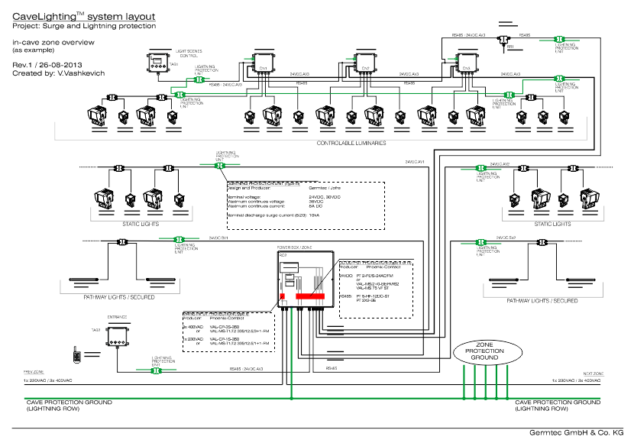
Illustration 2: schematic example of the overvoltage protection of a Cavelighting LED system.

The classified protection zones are characterised by a completely earthed mantle featuring complete electrical bonding. This is why electrical bonding is so important and always necessary!
Cables laid through this shield must be safeguarded by arresters in order to maintain a predefined level of protection. Further zones can be created within other protection zones and must only be safeguarded to a lower level. This leads to a coordination of the protection levels of the object to be protected. The separate protection zones ensure that a certain overvoltage level is not exceeded or may penetrate the system.
Modern lightning and power surge protectors must therefore cover several objectives. Whilst the classical lightning protector safeguards from material damage and danger to life, electrical and electronic systems within a structure require protection from electromagnetic lightning surge, whether via cable or radiated, by either direct or indirect strike. Beside the building infrastructure, all utility systems, including energy and information technology systems. The concept of power surge protection zones allows easy processing of even very complex protection tasks in show caves by the division into separate zones and distinct determination of interfaces. A risk analysis, careful electrical planning by technicians qualified in this field, calculation and dimensioning of the necessary protection components as well as the installation by qualified electricians and certification are necessary requirements.
Germtec maintains business relations to renowned manufacturers of lightning and power surge protection components such as “Dehn”, “Phoenix-Contact”, etc. for its installations.
In order to increase the fine protection we are developing special junction boxes for our LED systems.

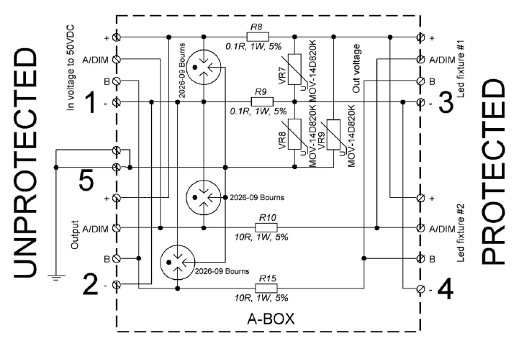
Illustration 3: Circuit diagram of a class 3 junction box for LED lamps

So do not hesitate to contact us in order to have the characteristics and selection criteria relating to lightning and overvoltage protection for your show cave professionally determined.
We have devised a questionnaire especially for show cave operators and will be glad to send it to you on request. Your electrical and electronic installations can then be checked in relation to power surge protection and thus ensure the trouble-free operation of your show cave.

