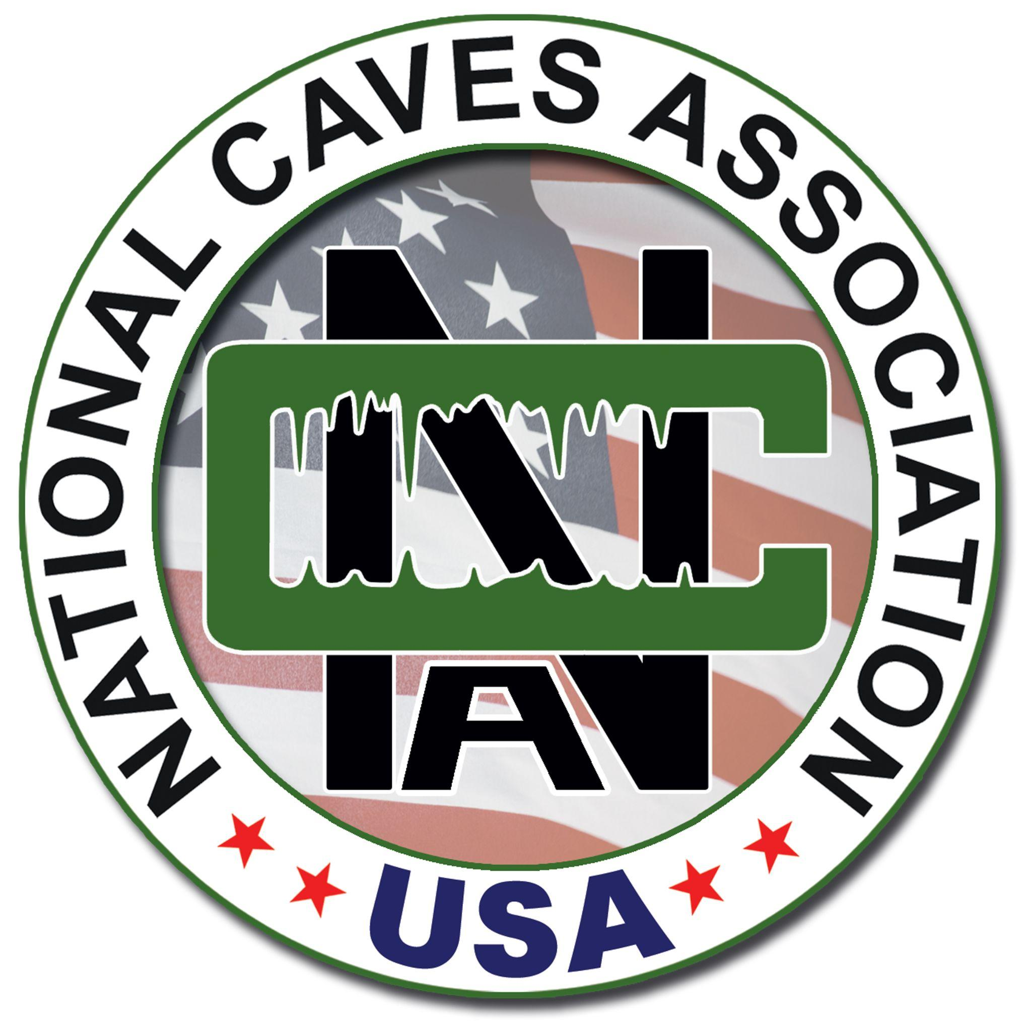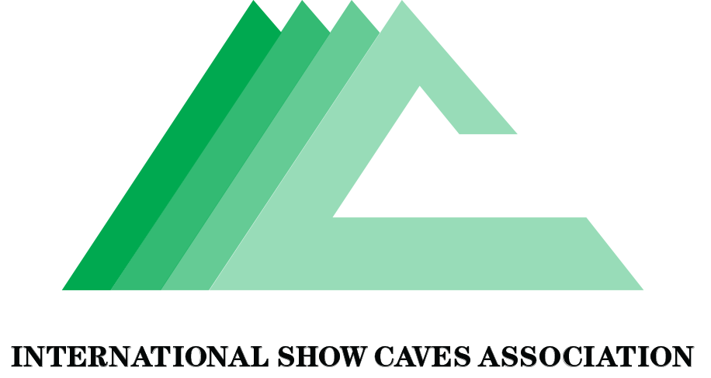

International Cave Day Fun Facts!

We are celebrating the International Day of Caves and the Subterranean World, aka, International Cave Day on June 6th! Here are some great facts about caves and karsts to share with guests and friends!

First of all - what’s karst?
- Karst is a landscape that’s typically characterized by rocky hills and outcroppings, sinkholes, caves, springs and aquifers. It is oftentimes hard to spot because it takes so many forms.
- Karst landscapes are home to hundreds of rare species of animals ranging from amphibious creatures like frogs, salamanders, fish, and crustaceans to mammals, reptiles, and birds.
- Karst areas are found on every continent in the world - except for Antarctica. ​
- Karst covers an estimated 20% of the world’s land surface.
- The word karst comes from the Latin word “crasus” which means rock or stony soil. There is a region known as “Kars” in Slovenia and northeast Italy.

Great! Now let’s talk about caves…
- Caves are incredibly diverse, and although most caves are found in karst, there are also caves outside of karst landscapes like lava tube caves, sandstone, and glacial caves.
- Caves can be decorated with speleothems or ice in colder climates. They can be filled with fresh water or under the ocean.
- Caves are rich in biodiversity and home to many plant and wildlife species -- some of which are only found in caves.
- Speleothems (cave formations like stalagmites and stalactites) take on average 100 years to grow one cubic inch.
- People have always loved caves too. The oldest known cave paintings in Europe are estimated to be 64,000 years old in the caves of Maltravieso, Ardales, and La Pasiega, Spain.
- Caves were economic generators even before people started visiting them, for example some caves were used as a source of bat guano for making gunpowder.
- Caves are diverse in length, size, and shape.
- Mammoth Cave in Kentucky, USA, is the longest cave on Earth and continues to increase in length as more passage is discovered, currently an astounding length of 663 kilometers (412 miles).
- Sarawak Chamber in Mulu National Park in Malaysia is the world’s largest cave room by surface area, with some 164,459 square meters (1,770,220 square feet) of expanse.
- Veryovkina Cave in the Eurasian country of Georgia is the deepest cave in the world at 2,212 meters (7,257 feet).
- Son Doong is located in Central Vietnam, in the heart of the Phong Nha Ke Bang National Park. It is considered the largest cave in the world, based on volume.

Ready to visit? Let’s talk about show caves!
- The oldest known show cave in the world is believed to be Reed Flute Cave in China with inscriptions from 792 in the time of Tang Dynasty.
- The first recorded cave tour in Europe was at Postojna Cave in Slovenia in 1213.
- Vilenica Cave, in Slovenia holds a record for being open to visitors and collecting entrance fees since 1633.
- Today, we believe that close to 150 million people visit show caves each year.

What about wild caves?
- Thousands of people around the globe explore wild caves every year. A wild cave is a cave that does not have public access but can be explored with landowner / governing authority permission. These caves do not have paved trails or artificial lighting. Some Show caves provide tours through “wild” sections of their caves.
- Wild caves are the great unknown. Along with the deep sea and space, caves are the last frontier of unexplored places by humans.
- International Union of Speleology and other speleological societies around the world work together to promote safe and responsible caving practices, effective cave and karst management, speleology, and conservation. Depending on their area of expertise, speleologists study the geological formation of caves, or the mineral deposits within caves, including stalactites and stalagmites. They may also study the creation of accurate and detailed cave maps, or the animals, insects, and microorganisms that live inside caves.
- Spelunkers are bound together by their love of caves and caving and their desire to learn about the underground environment and protect it for future generations.
- Some wild caves around the world are protected by local laws and regulation; some are not. Some wild caves are privately owned; others are part of a public trust like a national park system. Some wild caves have been extensively explored; some are being discovered every year.
- All caves have something unique about them and are worth protecting.

More! More! More!

There are great resources online to learn more. Visit any of these sites to learn more.

Find a show cave to visit near you (no spelunking needed!):
US: National Caves Association
Worldwide: International Show Caves Association
National Speleological Society (US): “Learn about Caving”
From the National Park Service (US): How caves and speleothems form
International Year of Caves and Karst: Celebrating Caves and Karst for two years with loads of information!

