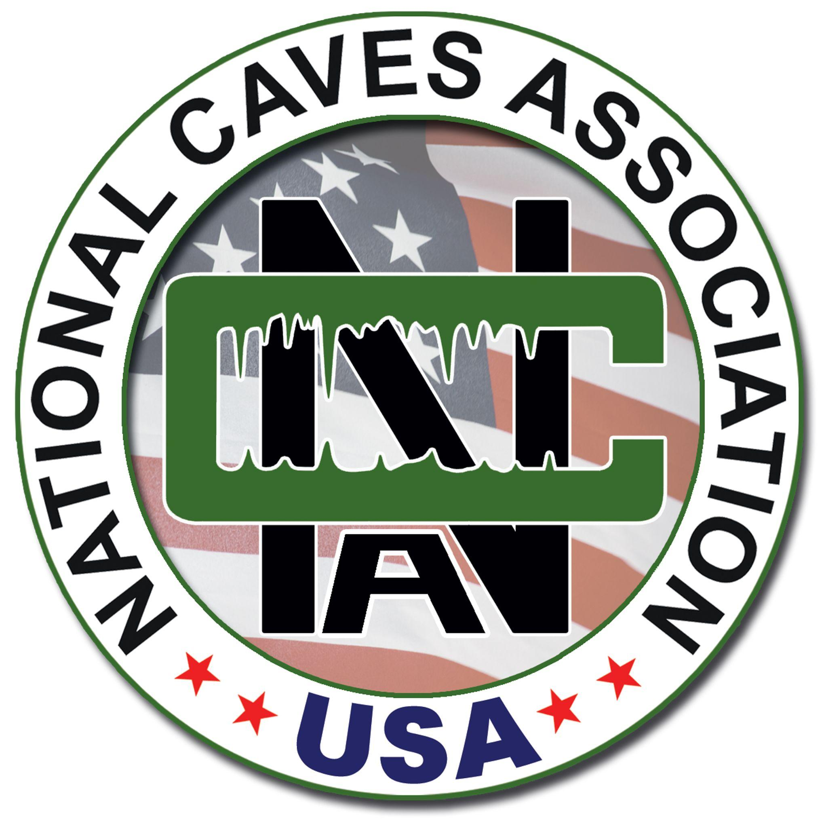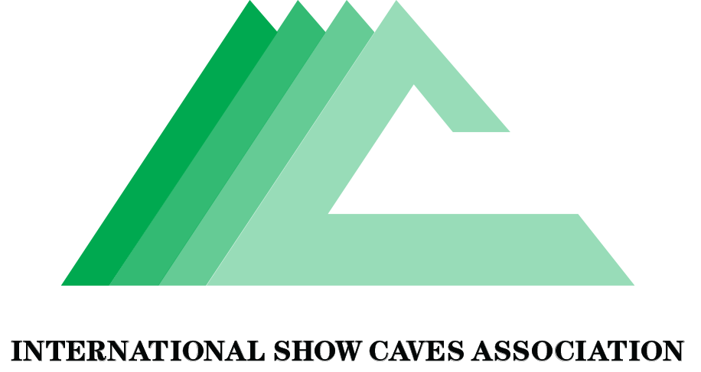

Staff Talking Points for International Cave Day

We’re excited to be part of the celebration of International Cave Day! Here’s what you need to know.

This is a worldwide celebration of caves and the subterranean world.

Today, with close to 150 million visitors, show caves like ours are among the most universally visited natural formations around the world. From Europe to Australia to South and North America, show caves bring families together.

This year multiple groups are taking part in International Cave Day around the world including the International Union of Speleology, the National Speleological Association and [Any local groups?]

Here is a list of great cave facts from around the world!

- Caves and karst landscapes supply 10% of the fresh drinking water to billions of people.
- Show Caves deliver tens of billions of dollars each year to economies through tourism.
- Caves serve as habitat for many important species such as bats which eat insects, pollinate, and disperse seeds, reducing pesticide use and supporting the production of foods, medicines, and industrial products.
- Caves are diverse in length, size, and shape.
  - Mammoth Cave in Kentucky, USA, is the longest cave on Earth and continues to increase in length as more passage is discovered, currently an astounding length of 663 kilometers (412 miles).
  - Sarawak Chamber in Mulu National Park in Malaysia is the world’s largest cave room by surface area, with some 164,459 square meters (1,770,220 square feet) of expanse.
  - Veryovkina Cave in the Eurasian country of Georgia is the deepest cave in the world at 2,212 meters (7,257 feet).

Here is a list of the ways we are participating:

[list of your plans!]

We have access to some great resources including an educational kit here [you could use the educational NCA kit. Feel free to review it, we will provide the link to guests.

Still have questions or ideas? Let [NAME know!]

